**DOMAIN NAME SYSTEM**

**PEMETAAN SERVER DOMAIN SITUS WEB**

**Dibuat Oleh :**

**Nama : Rizki Putra Ramadhan**

**NIM : 09011182126024**

**Kelas : SK6PIL INDRALAYA**

**Dosen pengampuh : Adi Hermansyah, M.T**

**FAKULTAS ILMU KOMPUTER**

**PROGRAM STUDI SISTEM KOMPUTER**

**UNIVERSITAS SRIWIJAYA**

**PALEMBANG**

**2024**

1. Domain shopee.id

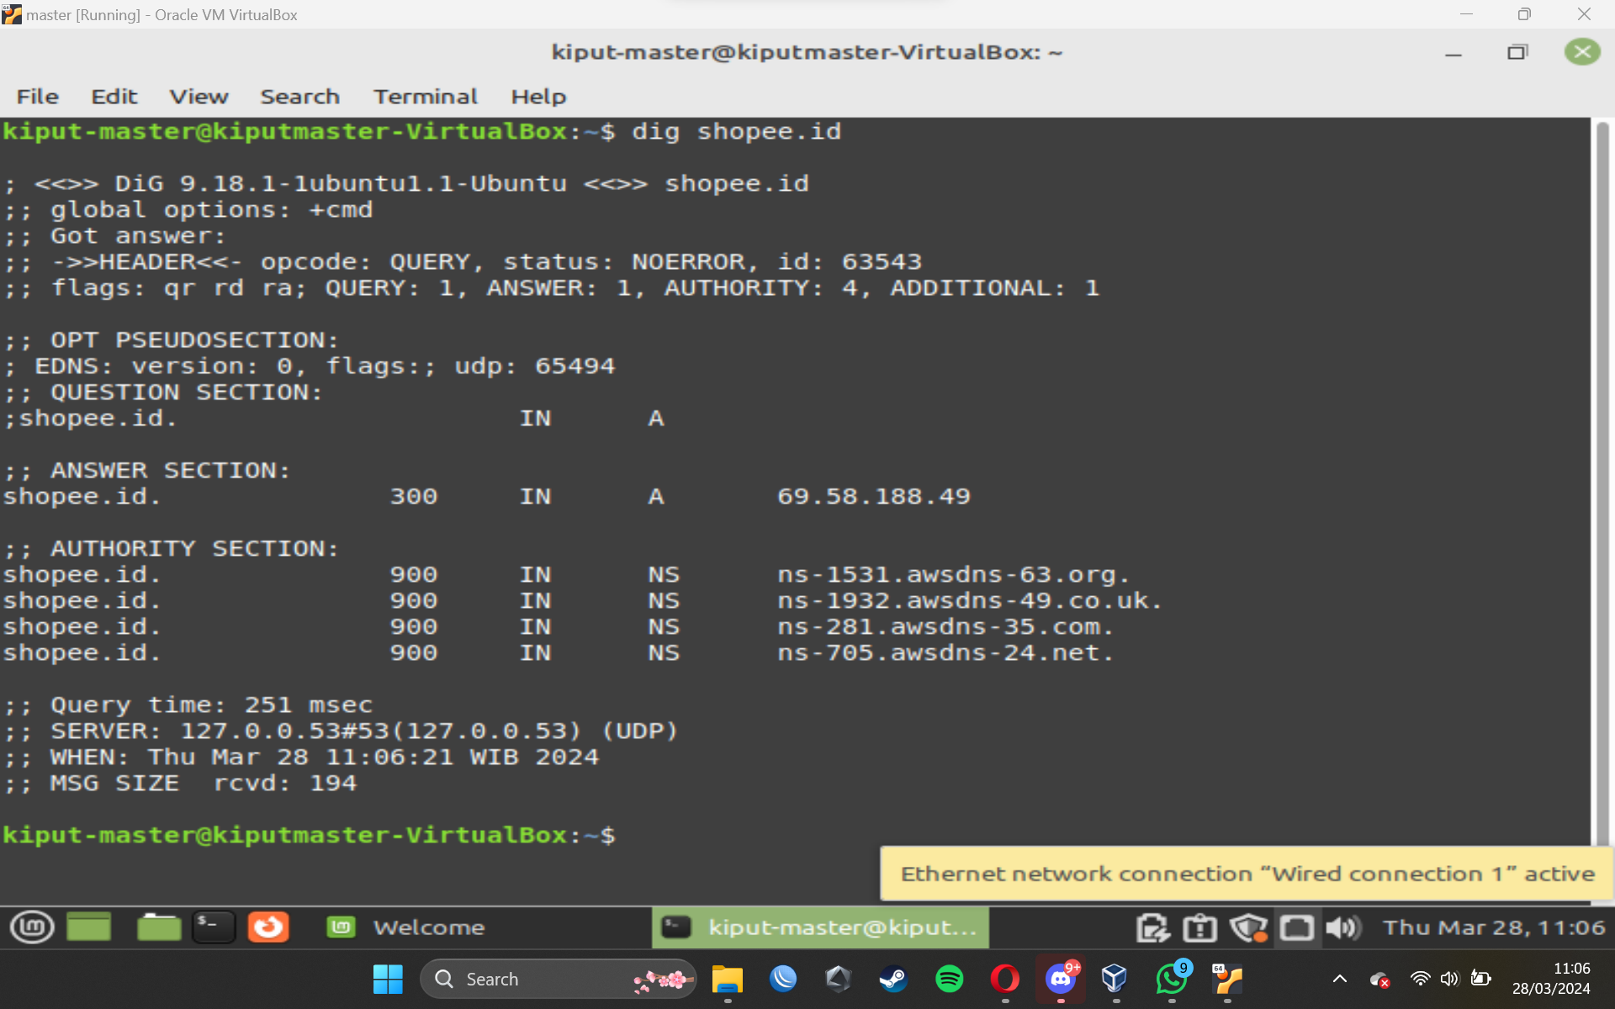

1. Domain Tokopedia.com

1. Domain facebook.com

1. Domain kemenkeu.go.id

1. Domain Microsoft.net

